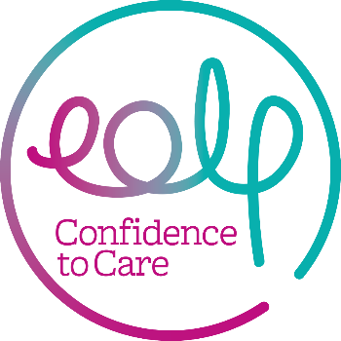

Declaration of Eligibility to be a Trustee

I declare that I am not disqualified from acting as a charity trustee and that:

- I am aged 18 years or over
- I am capable of managing and administering my own affairs
- I do not have an unspent conviction relating to any offence involving deception or dishonesty
- I am not an un-discharged bankrupt nor have I made a composition or arrangement with, or granted a trust deed for, my creditors (ignore if discharged from such an arrangement)
- I am not subject to a disqualification order under the Company Directors Disqualification Act 1986 or to an Order made under section 429(b) of the Insolvency Act 1986;
- I have not been removed from the office of charity trustee or trustee for a charity by an Order made by the Charity Commissioners or the High Court on the grounds of any misconduct or mismanagement nor am I subject to an Order under section 7 of the Law Reform (Miscellaneous Provisions) (Scotland) Act 1990, preventing me from being concerned in the management or control of any relevant organisation or body.

For charities that work with children:

- I am not subject to a disqualification Order under the Criminal Justice and Court Services Act 2000.

For charities that work with vulnerable adults:

- I am not disqualified under the Protection of Vulnerable Adults List.

Print Name:

Signed:

Date:

