Activity sheet 3: benefits/ risks/ burdens

Activity
Read the situation below regarding Peter and consider what are the benefit/s, risk/s and burden/s of the options available. Write your ideas and thoughts in the boxes below.

The situation

Benefit/s

Risk/s

Burden/s
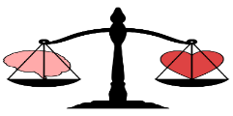

What would your decision be?

