Reflection activity ST4.1
Dignity
Activity:

Read the support sheet ‘Dignity’ that can be found in downloads in step 4. What does this mean to you and your practice and how you care for residents while promoting dignity? Give some examples of what you have done to provide dignified care and promote dignity for your residents (although do not name or identify them within this activity sheet).
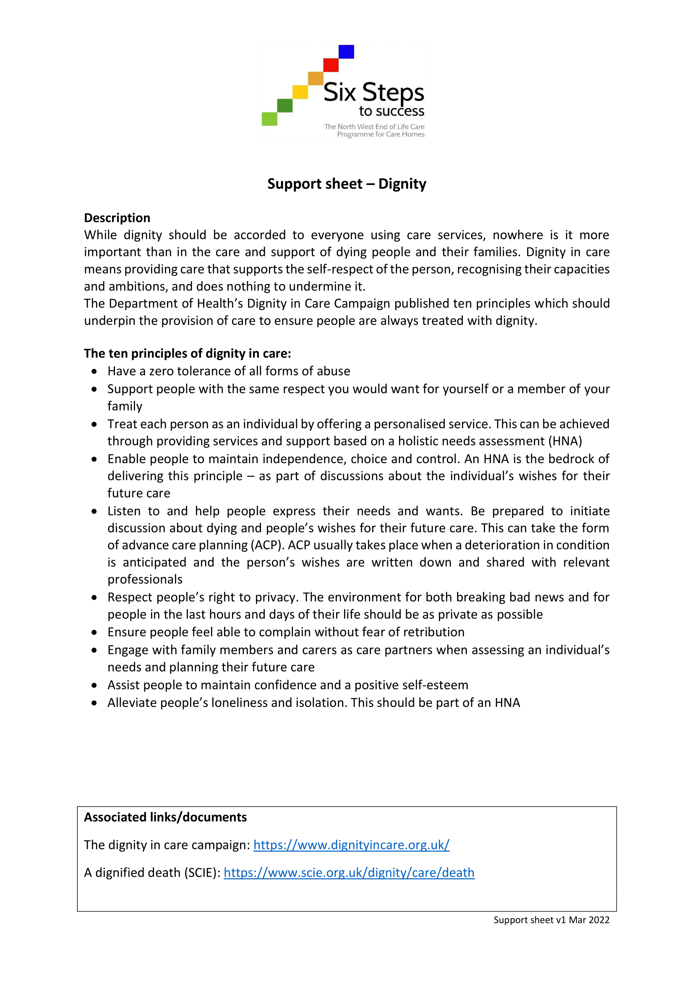

Your reflection:

