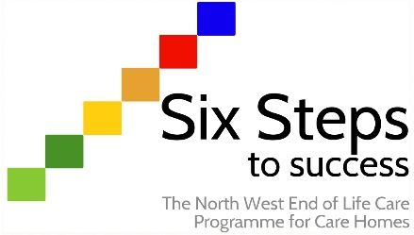

Worksheet ST3.1
What does the role of end of life champion mean to me?
Activity:

End of life champions are an important and integral part of the Six Steps programme and will mean different things for different people.

You are invited to read the Marie Curie blog ‘What does it take to deliver high-quality end of life care’ where a number of different people reflect on what it means to them. Once you have read the blog, complete the following exercise. Complete column 1 first (what does it mean to me) and return and complete column 2 (so what can I do)? Finally, reflect on any actions that you can take to develop your role.

Column 1 | Column 2
What does good end of life care mean to me? | So… what can I do as an end of life champion?

Action planning for myself:

