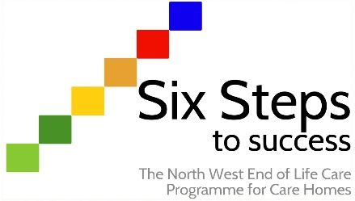

Worksheet ST1.1
Demonstrate an understanding of a Supportive Care Record
Activity:

On the Six Steps website under Step 1, you will find the Supportive Care Record (SCR). This is introduced when residents are entering their final year of life (although can be used earlier or even when it is difficult to recognise this time point with residents). The SCR is used as a guide to plan and deliver holistic end of life care.
You need to obtain a copy of the SCR for this exercise. Think of six residents that you are caring for, and decide whether they would benefit from having a SCR and if so, which phase would they be at.
Another way to consider this is to ask yourself the ‘surprise question’ (SQ). This has been used to identify patients at high risk of death who might benefit from end of life care. “Would I be surprised if this resident died in the next 12 months?”

Once you have completed this, fill in the exercise below and discuss it with your Six Steps programme lead/champion or a suitable member of staff.

How did you find completing this exercise?

Were there any residents that you were unsure about? Why?

Did the surprise question help with your thinking?

Is there any further learning that would help support you in using the SCR?

