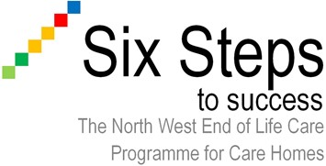

Role Description of the End of Life Care Home Representative (Champion) for Care Homes

Responsible to: Local Facilitator
Accountable to: Care Home Manager

Role Summary

- The care home representative will continually assess the quality of end of life care provision for residents, identifying gaps, and standardising practice across the care home
- Will be expected to take a lead role and support others to provide end of life care
- The care home representative will continually update their knowledge to understand national and local developments in end of life care and ensure this information is shared with the care home team
- The care home representative will facilitate the organisational change required to meet the Six Steps to Success outcomes
- The care home representative will be expected to take responsibility for their own learning and develop their own competencies in end of life care and support the development of knowledge and skills with the team

Key responsibilities

- Attend all of the Six Steps to Success programme sessions or workshops
- Implement changes with the organisation
- Implement support mechanisms to assist staff to identify residents who are approaching end of life
- Ensure Advance Care Planning and the Five Priorities for Care of the Dying Person are promoted and actively support the residents care
- Support the collection of data and complete the audits as required to develop practice
- To collaborate with the Facilitator and the Care Home Manager to build a portfolio of evidence to demonstrate learning and implementation of quality end of life care within the care home
- Work closely with the Local Facilitator to implement the programme within the care home setting
- To build relationships with the wider Multi-Disciplinary Care Team
- Facilitate the transfer of knowledge and information from the Six Steps programme to all members of the care home team including promotion and support of the individual Learning Log

