Evaluation form

We would welcome your feedback as it will help us to prepare for future workshops/sessions

Name: ___________________________________________
Workshop/session date: ___________________________________________

Q1 Please tick as you feel appropriate:

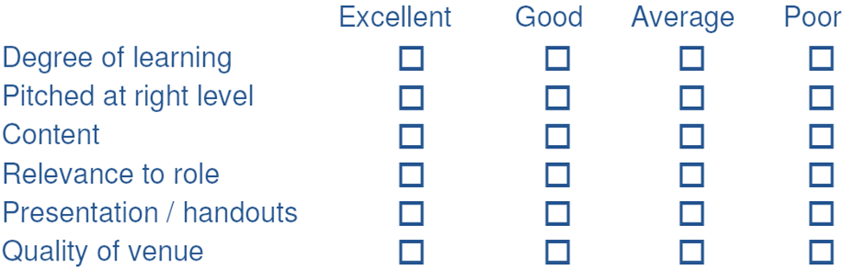

Q2 Were the learning outcomes clearly stated and effectively met?
________________________________________________________________________________________________________________________________________________

Q3 Did the facilitator demonstrate a sound understanding of the material presented?
________________________________________________________________________________________________________________________________________________

Q4 Would you have expected any other information relating to the topic to be included in the workshop/session?
________________________________________________________________________________________________________________________________________________

Q5 How will you use the knowledge gained to develop your practice?
________________________________________________________________________________________________________________________________________________

Q6 Please use this space to give us any further comments including ideas for further training, education or support. Continue overleaf if necessary.
________________________________________________________________________________________________________________________________________________

Thank you for your time in completing this evaluation form

