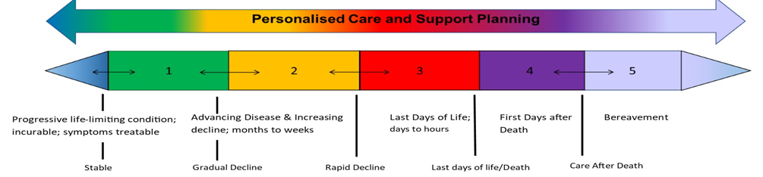

Supportive Care Record
Assessment based on  the North  West Model | End of Life Care Phases |  |  |  |  |  | Advance Care Plan Record
 | Incurable life limiting condition  Stable | 1  Gradual decline | 2  Rapid decline | 3  Last days of life | 4  Care after death | 5  Bereave-ment follow up | Date completed or declined | Review date – record any change | Review date– record any change | Review date– record any change | Review date– record any change | Key worker
Resident’s
Name
For example:  Jack Smith | 02/01/21 | 01/12/20 | 24/03/21 | 02/04/21 | 05/04/21 | Telephone  contact  17/05/21 | 01/12/21  Declined | 24/03/21  PPC Care home | 28/03/21  Care home | 02/04/21  Care home |  | Ann Jones

Assessment based on  the North  West Model | End of Life Care Phases |  |  |  |  |  | Advance Care Plan Record
 | Incurable life limiting condition  Stable | 1  Gradual disease | 2  Rapid decline | 3  Last days of life | 4  Care after death | 5  Bereave-ment follow up | Date completed or declined | Review date – record any change | Review date– record any change | Review date– record any change | Review date– record any change | Key worker
Resident’s
Name

Supportive Care Record v3 June 2021

