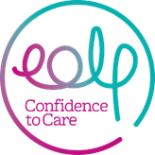

Pictures, Post Cards and Pebbles

Cheshire Care and Nursing homes cannot accept visitors at the moment as they try to keep their residents and staff safe.

But they would love to hear from their communities..

Could YOU to write a postcard, draw a picture or paint a pebble (and varnish it) for the residents and staff?

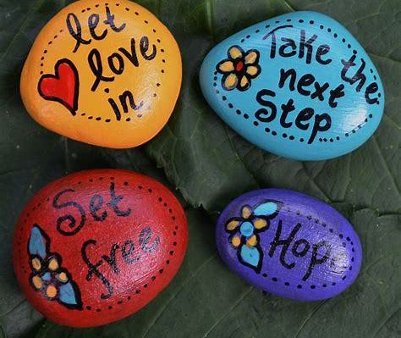
Pebbles can be dropped in the Entrance Porch at each care/nursing home.

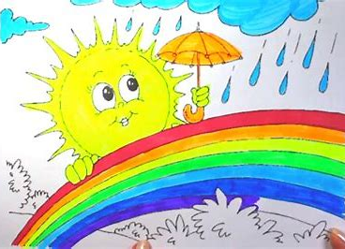
Picture and postcards can be sent to;
Address here
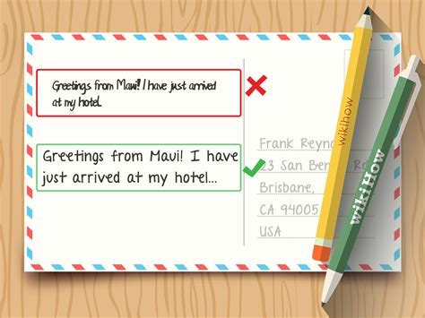

Thank You
Everything we receive will bring add a smile to someone’s day.

