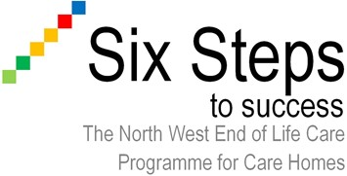

Margaret - a case study with a CVA

Margaret is a 66 year old lady who has recently been admitted to your care home following a stroke.

The stroke has left Margaret with a severe left sided weakness for which she did initially receive physiotherapy but there was no significant improvement.

Currently Margaret is nursed in bed or her chair and the hoist is used for transfer. Margaret is only able to tolerate a puree diet with thickened fluids and continues under the care of the Speech and Language Therapist.

Margaret requires a high level of care with all activities of daily living; this appears to frustrate Margaret.

Time is allowed to encourage Margaret to express herself as the stroke has made it difficult for Margaret to verbally communicate. Margaret is a widow with three children and seven grandchildren. Before the stroke Margaret had been very involved in supporting her two daughters and one son with childcare whenever possible.

Margaret is a Christian and has always enjoyed attending church with her two friends. Margaret frequently volunteered in the church and regularly baked with her grandchildren to raise funds for the church. Margaret has been very emotional since the stroke and frequently cries when care staff attend to her.

What are Margaret’s needs from a holistic perspective and how would you address them in her care plan?

