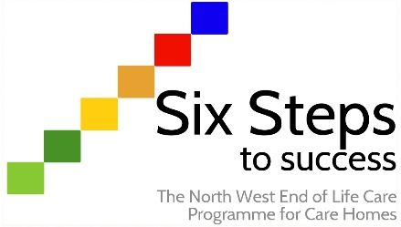

Worksheet ST4.2
Be able to identify and meet the spiritual needs of residents
Activity:

Watch the short video that has been produced by the Irish Hospice Foundation and complete the following questions.
The video can be viewed at: https://www.youtube.com/watch?v=zIhxGvC5Ux8&t=71s

What does spirituality mean to you?

Having watched the video, has it changed the way in which you think about spirituality?

How can you better identify and meet the spiritual care of residents in your care home? Please make some notes, then complete the action plan.

Notes to myself:

Area/aspect of care to develop/improve | How I will do this (and include others in my team)

