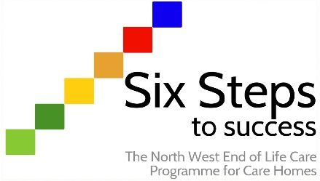

Worksheet ST3.2
Taking part in an Significant Event Analysis
Activity:

A Significant Event Analysis (SEA) allow teams to highlight and learn from both strengths and weakness in the care provided, specifically in relation to a situation or issue that has taken place.

Within step 3 of the Six Steps programme, your end of life care champion/lead will be learning about SEAs and will be inviting members of staff to take part in an SEA when the opportunity arises. You can find information about the process and the template used to carry out an SEA under step 3 resources.

Once you have been involved with an SEA, you will be asked to reflect on it using the following questions. Complete the following and discuss with your Six Steps programme lead/champion or a suitable member of staff.

Have you ever been involved with an SEA before?

How did you find the process?

What did you learn as a result of being involved with the SEA?

Would you change anything about the process in future?

