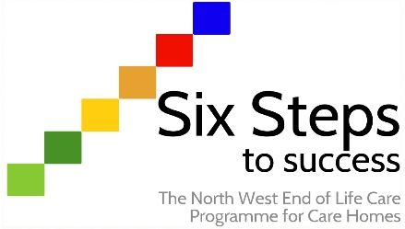

Support sheet - Enhancing the Healing Environment
Description
It is recognised there is a direct impact that the physical environment can have on the experience of care for people at the end of life and on the memories of their carers and families. Central to this is the importance of providing an environment for residents, relatives and the bereaved in which privacy, dignity and respect are facilitated.

Key design principles for end of life care environments
- Fit for purpose
- Comfort and human scale
- Connection with nature
- Use of natural light and natural materials
- Legibility and way finding
- Comfort, dignity and privacy
- Robustness, sustainability and economy

Improving experience
- First impressions count: uncluttered spaces and intuitive way finding create a professional impression and reduce stress
- Good design should enable residents to control their environment from their bed
- For residents at the end of life, access to nature is important: glimpses of greenery though a window or internal planting can help if garden access is not possible
- Senses are heightened at the end of life; touch, taste and smell as well as sight and sound all need to be considered (look at the Namaste programme for ideas)
- Artwork can provide distraction and lift the spirits of residents and relatives
- Informal spaces for 1:1 conversations should be provided
- Spaces where people can feel private but not alone are important for residents and visitors
- Viewing facilities of the deceased should meet the needs of a multicultural society

Tips for managing an environmental improvement project
- Form a multidisciplinary group, including estates staff, to review the current environment and manage changes
- Talk to residents, relatives and staff about their current impressions and any plans
- Audit the use of the area and current operational and clinical policies
- Check feedback on care, there may be comments about the environment
- Develop a plan and budget for the project
- Aspire to high quality and design standards
- Consider engaging additional support, while a designer may not be available, there may be local services who can support you
- Be brave and once finalised stick to the plan!

