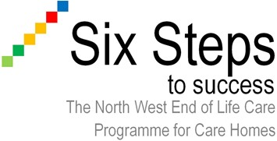

Step 2 Care Plan

Physical
Psychological
Spiritual
Social

Care Plan V2 Feb 2015

